The Great Zombie Hunt
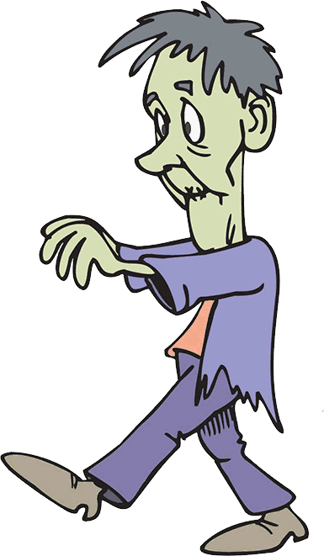

An interactive Halloween game for staff and residents.
Objective
The Objective is for the residents to collect as many zombie cards from staff members as they can in the allotted time (60 minutes).
Equipment Required
Print a number of copies of the 4 Zombie cards below. How many cards are required is dependent on the number of residents likely to participate and staff available for the time period. (Note: staff can continue their normal routine for this activity). Rewards I used for 1st, 2nd and 3rd were laminated certificates (see example below) and optional vouchers for the canteen.
Organisation
Cut out the cards and mix them up (shuffle if you can). Without looking at the front of the cards put an equal amount in envelopes for the staff to hold. A mix of 6 cards for each staff member should suffice.
Encourage staff to participate and advise them that when residents approach them and say ‘Trick or Treat’ the staff member responds as follows:
The staff member will either say ‘Treat’ and hand the resident a card without looking at it (this ensures that favourites are not given the best cards), or ‘Trick’ and not hand out a card. The reason for not handing out a card may be because the staff member has run out of cards, or they have already given the resident a card.
Running the Activity
Prior to telling the residents the objective and rules of the activity hand out the prepared envelopes to staff.
Gather the participating residents and let them know the following:
- A Number of Zombies have gained entrance and are roaming the facility. Your objective is to capture as many of these Zombies as you can in the next 60 minutes.
- To capture a zombie you need to approach a staff member and say ‘Trick or Treat’. Note: You may only approach a staff member once during the activity to ask for a card.
- The staff member will either say ‘Treat’ and hand you a card, or ‘Trick’ and not hand you a card. The reason for not handing you a card may be because they have run out of cards, or they have already given you a card.
- Commence the activity.
- At the end of the time period have the residents return to the meeting area to hand in all the cards they have collected. Note: Although one resident may have collected more cards than another resident, they might not win. This is because the cards are not all the same – some have one Zombie, others have 2 or 3 Zombies.
- After totalling the number of zombies collected announce the winners and present the certificates (make sure you take photos of the recipients with their certificates) and, if choosing to do so, present the gift vouchers.
Benefits from this activity
- It is a fun and safe activity to run on Halloween.
- Residents in wheelchairs have just a good a chance of winning the hunt.
- It is a good opportunity for staff to interact with residents in a social rather than work-related encounter.
- Cost is minimal and there is little disruption to the everyday routine of the staff.
Note: This activity could also be adapted for The Great Egg Hunt at Easter, or The Great Leprechaun Hunt for St Patrick’s Day.

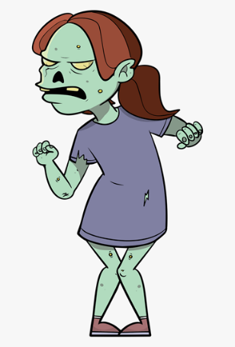  2 | 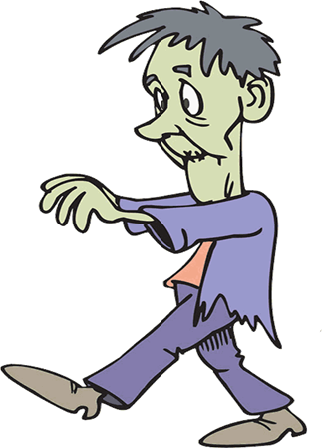  1
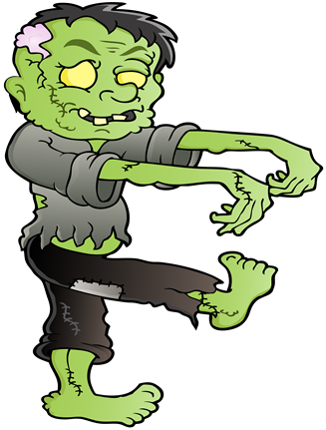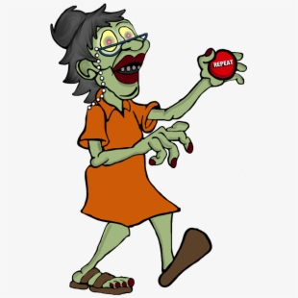  2 | 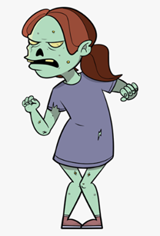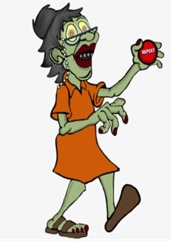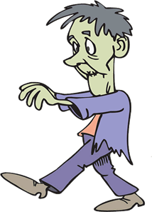  3

The Great Zombie Hunt
October 2019

Be it known that
(Resident’s Name)
Is declared the
(Name of Home)’s
First Class
Zombie Hunter
